# Tautvydas Petkus IFF-1

# Lab 4. Issue tracking systems

## Lab goal:

Use issue tracking system during intermodal terminal software development, in testing and developing activities.

## Prerequisites:

1. Used intermodal terminal software to test
2. The test plan has been prepared containing some test scripts.
3. Some issues have been detected during labs 2 and 3 execution.

## Background

During the software development project the various amounts of bugs are detected and fixed. The bugs are usually discovered by a team of testers and fixed by a team of programmers. To facilitate bugs reporting and fixings activities monitoring and coordinating the issue tracking system is used.

The usual features of issue tracking systems are:

1. Register a discovered issue, give its reproduction scenario.
2. Assign issues to for development team members to fix.
3. Monitor issue fixing progress.
4. Obtain detailed reports about bug found/fix ratio. Determine is the project has reached stabilizing phase, is it nearing its completion.

The issue tracking tool can also be used for managing project tasks, requirements, by using special issue types, like task, requirement, and improvement.

Issute tracking system to be examined – Jira.

## Lab work tasks:

The mini software development process is used:

1. Student assigns roles to team members, (who are developers, who are testers).

Jira offers easy overview of all project roles and gives good access to moderate them.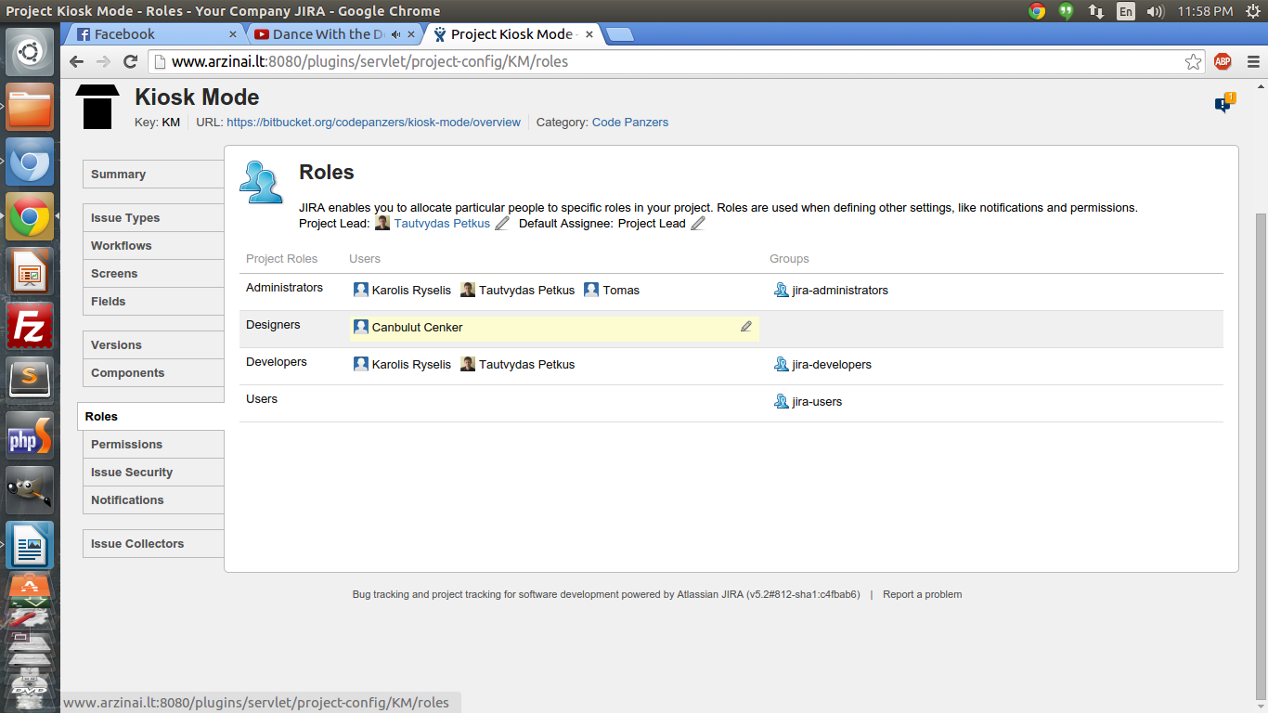

1. Trac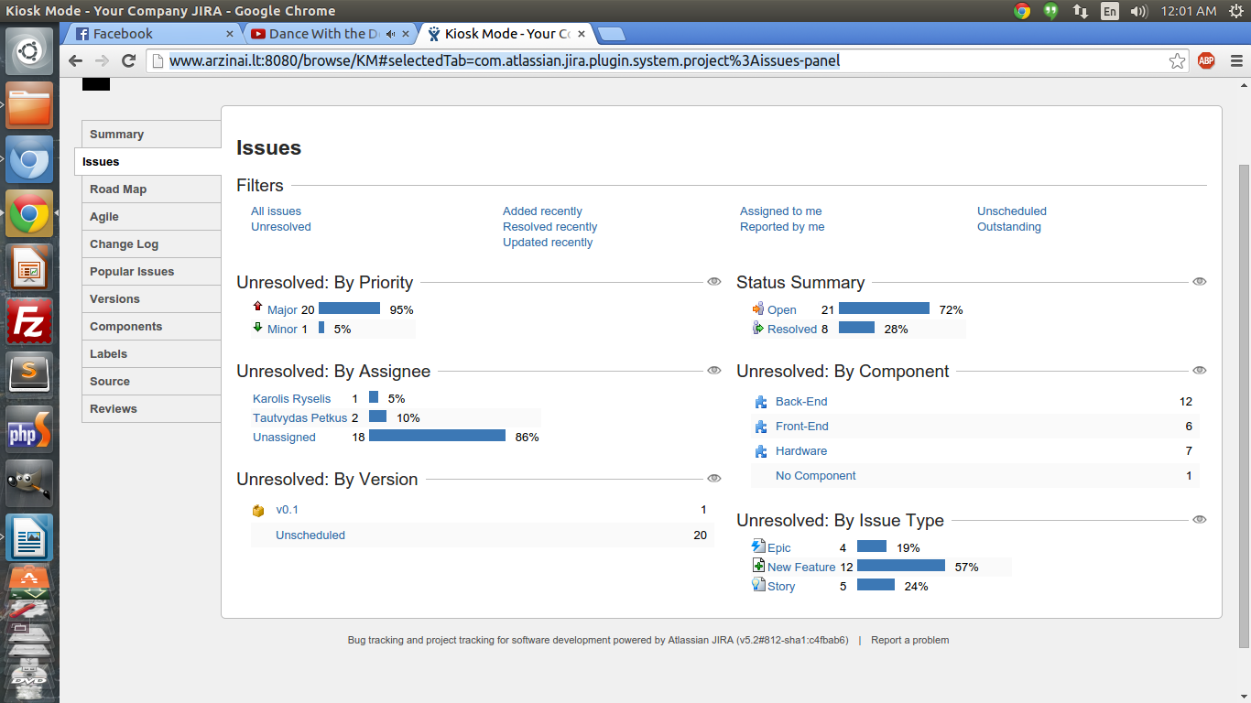k issue management system is installed and ready to use at [http://www.arzinai.lt:8080/browse/KM#selectedTab=com.atlassian.jira.plugin.system.project%3Aissues-panel](http://www.arzinai.lt:8080/browse/KM" \l "selectedTab=com.atlassian.jira.plugin.system.project%3Aissues-panel)
2. Initial setup of issue tracking system: create users, create project.
3. Create subproject for test activities planning.

Here we can create components for our project. For example front end issues, testing issues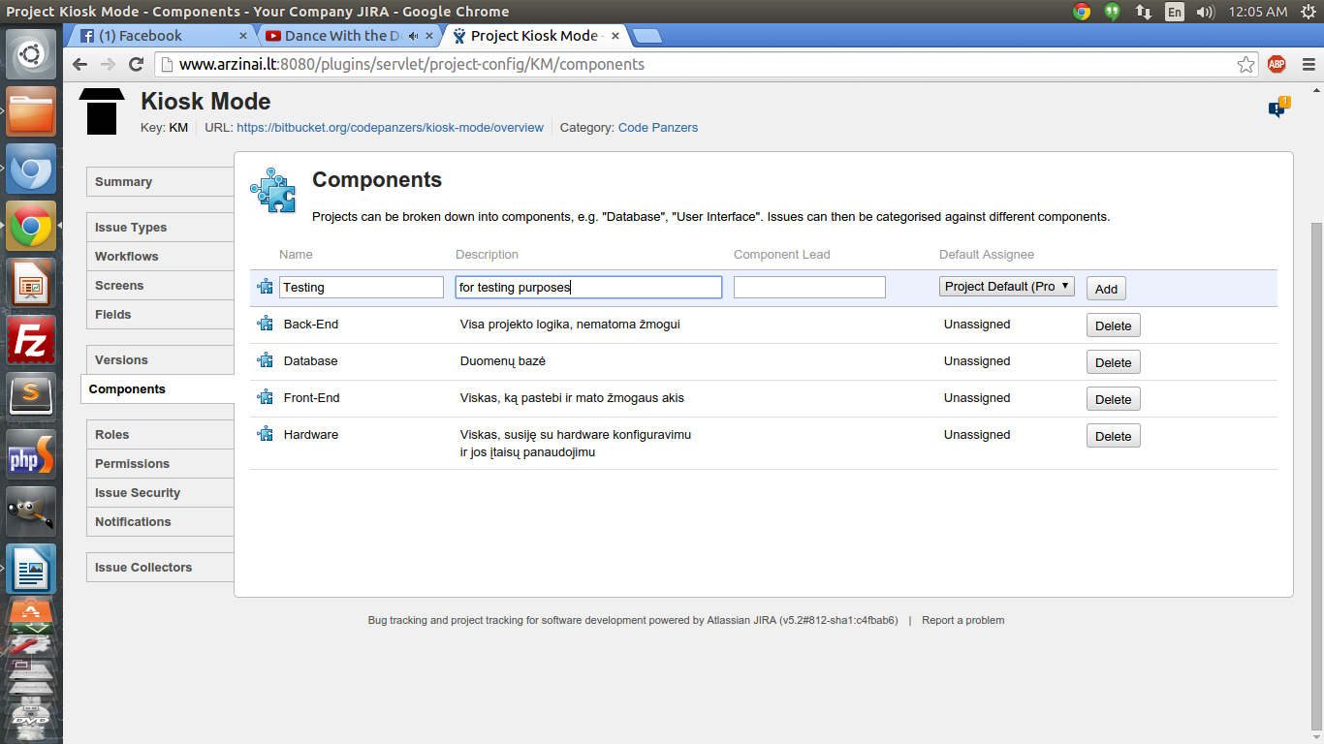

1. Create subproject for bugs  
   Component for bug tracking added.
2. Register testing activities plan: create tasks for each planed test in “testing activities” subproject tasks from the 1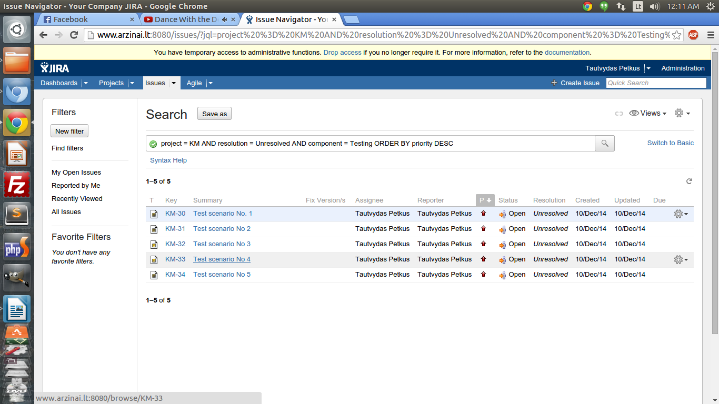st lab.  
   Created 5 issues for testing component
3. Assign testing activities to team members.  
   Assigned to myself
4. Perform testing (2nd and 3rd lab).
5. Register discovered bugs into bus subproject. While registering describe steps to reproduce or specify concrete test that failed, the test data that was used and detected a bug.  
   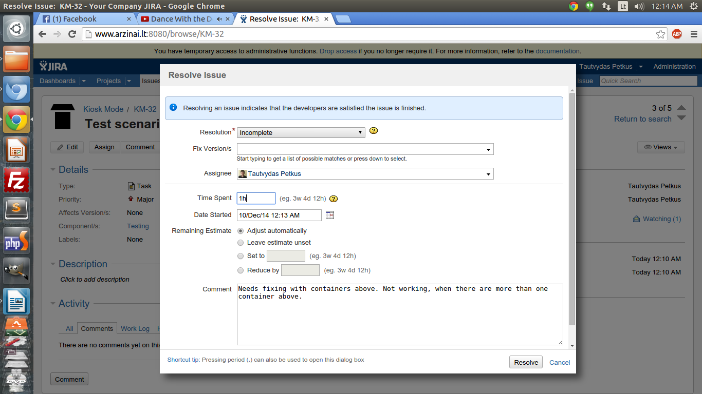Detected bugs. Reported to the Jira. Leaved comments, changed issue status and assigned to the user to fix it.
6. Assign bugs to fix to some team members.
7. After fixing bug change issue status to resolved, cannot reproduce etc.  
   Issue resolved, it status changed.
8. Extract bug tracking report from the issue management system.  
   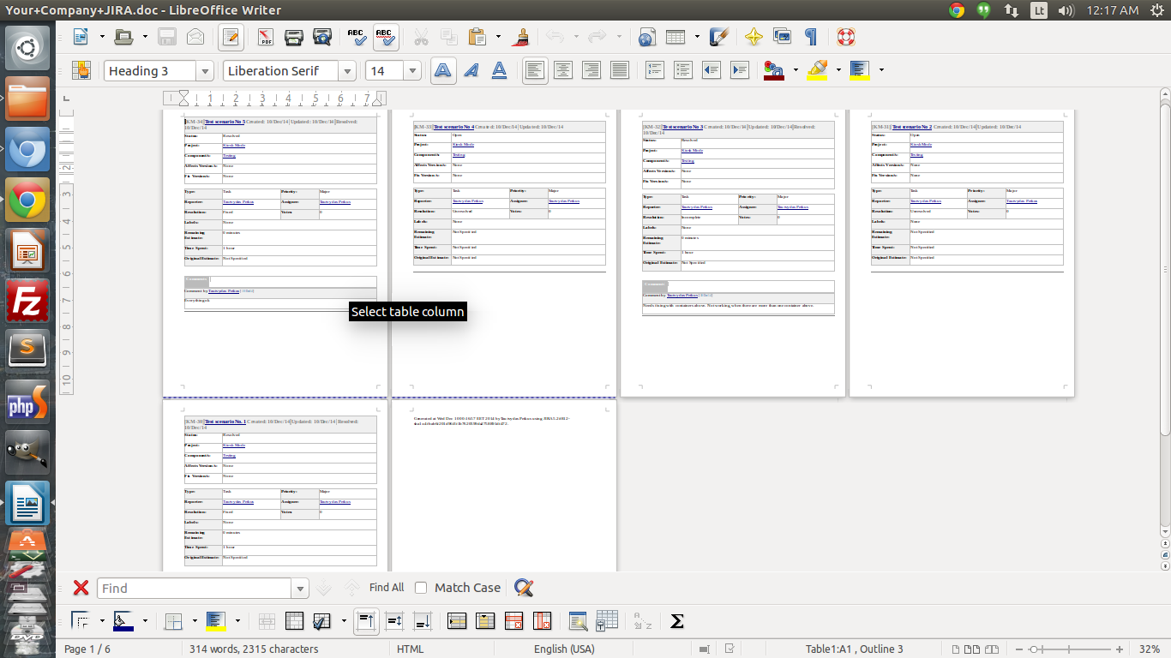Component issues extracted to word document and presented for analysis